English Bulletin of Classes: Summer/Fall 2022 and Spring 2023

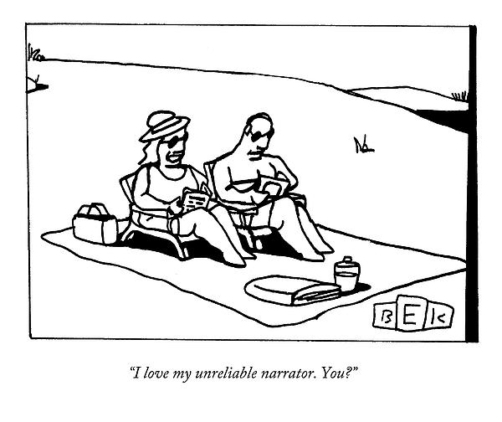

Note to Majors: We are delighted by your interest in our English classes, and we look forward to working together. One word of advice: Upper level classes are challenging, with strong reading and writing requirements. Please ask yourself how many upper level classes you can really take well in one semester, without throwing the course reading overboard or writing hastily and regrettably. The department, in general, recommends no more than two upper level English courses in a given semester. Also, we have observed in past semesters the custom of students registering for a number of upper level classes, only to drop them at some point “later” in the process. This practice can clog up registration and create enrollment headaches for your peers and our waitlists. As Hamlet counsels, “Pray you, avoid it.” We wish you the best on your intellectual growth, and we look forward to sharing our love of great literature with you. Those interested in great humanities electives are welcome as well to our courses.

Note to Future Majors: We are happy that you are interested in the English major, and we welcome you to join our community of teachers, thinkers, and writers. If you choose to major in English, be sure to declare your major with the Registrar and transition to an advisor in the English department. If you have any questions about the English major, please feel free to make an appointment with the department chair. For those starting out on the English major, the best course of action is to make your way through the 300s (the core of our major) to the 400s (our seminars), with good and deliberate order. You will note, for example, that many 400s have a specific 300 as a prerequisite. Your major advisor will help you choose a good path through the major program and beyond.

Note to English 104 Students: As you know, English 104 is our required core course, which all students must take in the Spring semester. Please be sure to register right away in an open section of 104; those who choose not to register will be placed in open sections later by the Registrar.

Note on writing requirements at the 300 and 400 level: Students should expect a substantial paper (10-15 pages) at the 300 level and a substantial paper (15-20 pages) at the 400 level, along with exercises such as annotations and the annotated bibliography.

Fall 2022: 200-Level English Classes

Note on writing requirements at the 200 level: Among other assignments, students should expect a 5-page paper focused on the primary text and a comprehensive final exam.

ENG 201-01 TTh 9:30-10:45am: Dr. Justin Jackson
ENG 201-02: TTh 2:30-3:45pm: Dr. Stephen Smith

This tier-two literature core class introduces students to select great books of the Continental literary tradition from the Renaissance to modern times. Some emphasis will be placed on the literature in the context of general historical and artistic periods and movements. Authors may include Petrarch, Erasmus, Montaigne, Cervantes, Voltaire, Goethe, Rousseau, Flaubert, Tolstoy, Dostoevsky, Kafka, Camus, Sartre, and Solzhenitsyn.
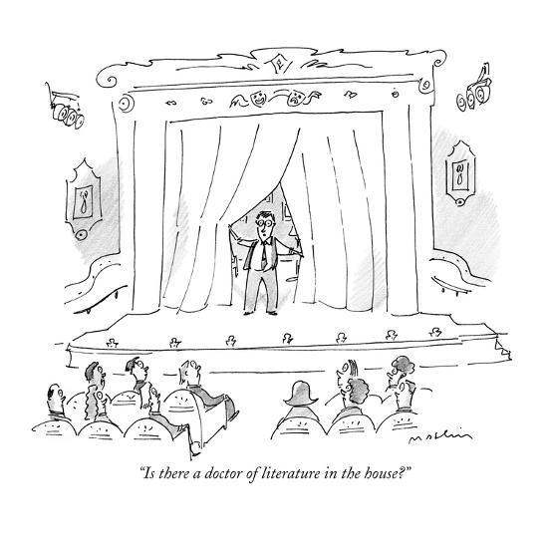

Fall 2020: 300-Level English Classes

Note on writing requirements at the 300 and 400 level: Students should expect a substantial paper (10-15 pages) at the 300 level and a substantial paper (15-20 pages) at the 400 level, along with exercises such as annotations and the annotated bibliography.

ENG 310: Anglo-Saxon and Medieval British Literature
Dr. Patricia Bart
TTh 6:00-7:15pm

Hwæt? This fall, go medieval on English literature. Þæt’s hwæt.
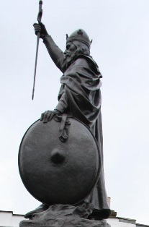
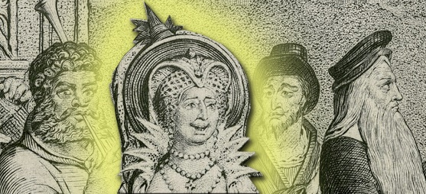
🙧 This term, hear the sounds of the Anglo-Saxon mead hall thundering through the halls of the College. 🙧 Experience a live demonstration of early medieval battlefield conditions while learning the words—lost to modern parlance—that the Anglo-Saxons used to describe them. 🙧 And then, for something completely different, a loud-mouthed rooster will lecture on theology. 🙧 A wily and amorous graduate student, a big-haired fop, and the fop’s burly blacksmith wingman will get a gruesome comeuppance. 🙧 A boisterous widow—often married but never satisfied—will menace both a Doctor of the Church the very author who has made her a legend. 🙐❖🙖 As a jolly kickoff to Christmas dinner, a green man with blazing red eyes will ride his horse into the dining room and get his head cut off by an outraged guest, only to walk away with it, still hurling insults. 🙧 Not one, but two men will awaken to find a beautiful lady hovering over their beds. 🙧 A king will cry out to God in grief because he lacks a liberal arts education, but will then make good by translating key Latin works for his ambitious nationwide educational program, while defeating a Great Heathen Army in his free time. 🙧 And not to be outdone, a vicar of the Evil One will get tossed in a blanket.
🙧 A thousand years of resplendent literary history await. 🙤
🙧 When Downton Abbey Hillsdates The Walking Dead, how can you stay away? 🙤
Requirements: The departmentally prescribed two papers, a midterm, and a final. There will be a 10-15 page research paper with an annotated bibliography leading up to it. Coaching in research writing through a long-form prospectus and tutorial will be at your option.
Reading List: Caedmon’s Hymn, Boethius’s Consolation of Philosophy, Saint Augustine’s De Doctrina Christiana, Beowulf, “The Battle of Maldon,” various works by and about Alfred the Great, a sampling of Corpus Christi plays, Sir Gawain and the Green Knight, and select Canterbury Tales.

Images: Hamo Thornycroft’s memorial to Alfred the Great, Winchester, England—CCBY 2.0 Jon’s pics; detail from William Blake’s engraving of the Canterbury Pilgrims (Miller, Wife of Bath, Merchant, Parson), public domain.

ENG 320: Renaissance British Literature, 1500-1660

Dr. Benedict Whalen
MWF 1:00-1:50pm

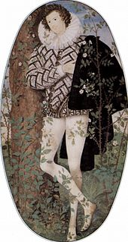
Alas! what boots it with incessant care
To tend the homely, slighted shepherd's trade,
And strictly meditate the thankless Muse?
—John Milton, “Lycidas”

This course is an introduction to the literature of the English Renaissance. Conducting a survey of the major authors from the early modern period, we will study their works in their literary, philosophical, political, and theological contexts. Major works covered will (tentatively) include: More’s Utopia, Spenser’s The Faerie Queene (Book 1), Marlowe’s Doctor Faustus, several of Shakespeare’s plays, and Milton’s Paradise Lost. The course will also include a substantial selection of the lyric poetry from the period, including works by Sidney, Spenser, Shakespeare, Donne, Herbert, Herrick, and Marvell, among others.

Requirements: Two papers, exams, regular reading quizzes, and poetry memorization

ENG 330-01: Restoration and Romantic British Literature, 1660-1830
Dr. Lorraine Murphy
MWF 3:00-3:50pm
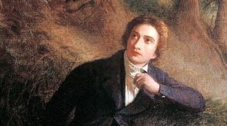
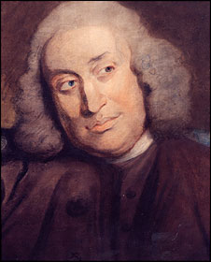
Our study of British literature extends from the Restoration of Charles II in 1660 to the close of the Romantic Movement in 1830. During this time, an aesthetic transformation was achieved with implications extending to every corner of culture and society. We live today in a world imagined by the Romantics, for in their revision of literary conventions they persuasively reconceived the relationship between language and reality. Over the course of the semester we will acquaint ourselves with this aesthetic revolution by immersing ourselves in some of the period’s greatest works.

Requirements: short response papers, a research essay with bibliography, a mid-term exam, and a comprehensive final exam.

ENG 340: Victorian and Modern British Literature
Dr. Elizabeth Fredericks
MWF 1:00-1:50pm
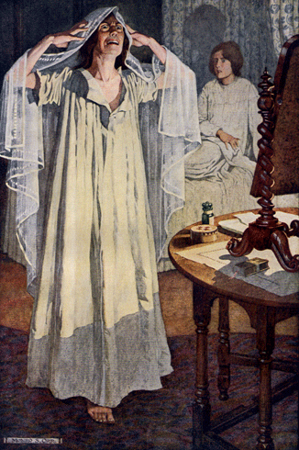
This course is an introduction to Victorian and modern literature, in which we will follow our writers’ fascination with the secrets and mysteries of human experience as captured in prose and poetry alike; we will also explore how cultural and historical contexts shaped the subject matter as well as the styles and forms of the texts that we will read. By the end we will see how changes in religious life, social organization, and the effects of colonialism and two world wars altered how people understood their world and their place in it, as well as their awareness not only of everything they could know, but of all that remained mysterious or undiscovered. Works will include: Charlotte Brontë’s Jane Eyre, Oscar Wilde’s The Picture of Dorian Gray, T. S. Eliot’s The Waste Land, E. M. Forster’s Passage to India, and Jean Rhys’s Wide Sargasso Sea, as well as selected poetry and short stories.

Requirements: Coursework includes six short reflective writings, a research paper, and midterm and final exams.

ENG 360: Romanticism, Renaissance, and Realism: 1820-1890
Dr. Jason Peters
TTh 1:00 PM – 2:15 PM
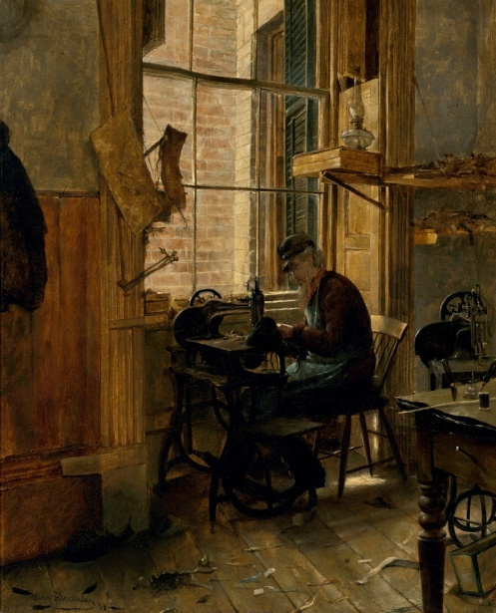
A survey of American literature from 1820 to 1890, this course will examine the work of critical figures associated with American romanticism, including William Cullen Bryant, James Fenimore Cooper, and Washington Irving, and will give special attention to the great writers of the American Renaissance: Edgar Allan Poe, Walt Whitman, Emily Dickinson, Ralph Waldo Emerson, Nathaniel Hawthorne, Henry David Thoreau, and Herman Melville.

Requirements: 10-15 pages of writing; an annotated bibliography; midterm exam; comprehensive final.

ENG 370-01: Naturalism and Modernism: 1890-present
Dr. Brent Cline
MW 11:00am-12:15pm

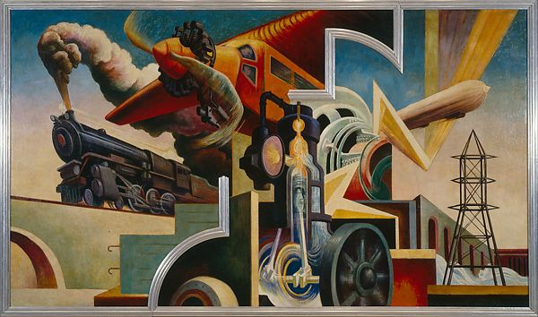
If the 20th century witnessed the rise of America's political power, the country's literary explosion was no less impressive. In this introduction to naturalism and modernism, we will try to experience some part of the wide range of America's literary output. Readings will include Ernest Hemingway, William Faulkner, Arthur Miller, Flannery O'Connor, Ralph Ellison, J.D. Salinger, and Toni Morrison.

Requirements: annotated bibliography, short close readings, final paper (10-12 pages), and comprehensive final.

ENG 393-01: Creative Writing Honors Program in Fiction
Prof. Chigozie Obioma
F: 2:00-4:00
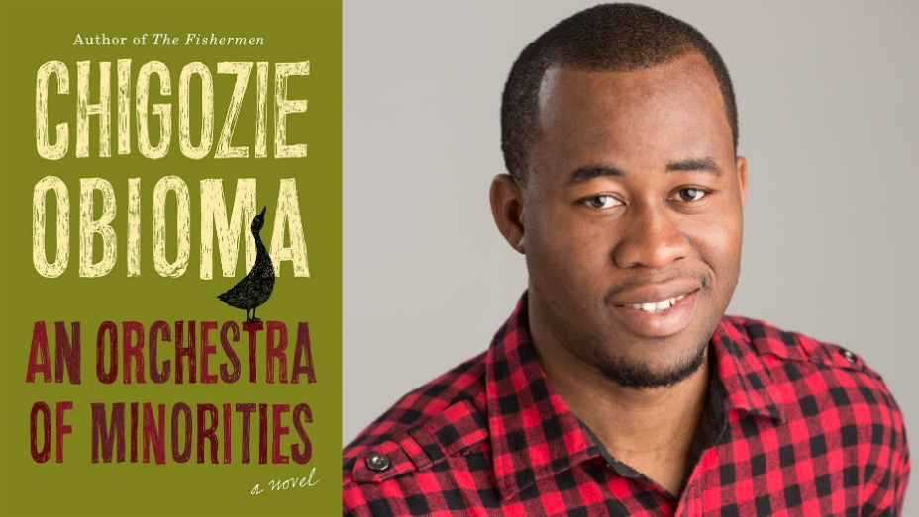
Fall 2022 marks the inaugural class of Hillsdale College’s Creative Writing Honors Program. This course will be taught in a hybrid style, both online and in-person. Students will learn the craft of fiction, how to annotate stories and books, as well as how to be a helpful peer reviewer. Students will write and workshop two stories between 5 and 20 pages each, produce in-class writing, and participate in discussions.

Requirements: attendance (10%); participation (10%); in-class writing & assignments (20%); craft exam (20%); fiction portfolio (40%).

Reading List:
The Art and Craft of Fiction: A Writer’s Guide by Michael Kardos (2nd ed.)
The English Patient by Michael Ondaatje
Wyoming Stories by Annie Proulx
The Road by Cormac McCarthy

* * *
Enrollment is limited to ten students. If you wish to enroll, email a copy of your best work of fiction (5-20 pages), along with a note of your class standing, to Dr. Kearney by April 15, 2022 at 5:00pm. Your story is your application. Dr. Kearney will send your story to Professor Obioma, who is be responsible for the final decisions. Selected students will be added to the class after registration.
* * *

ENG 401-01: Wordsworth and Keats
Dr. Dutton Kearney
TTh 1:00-2:15pm

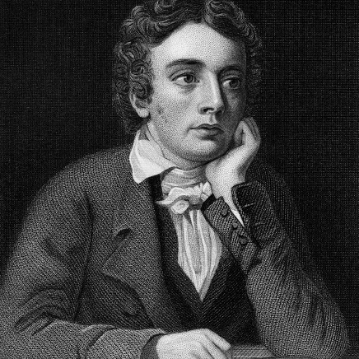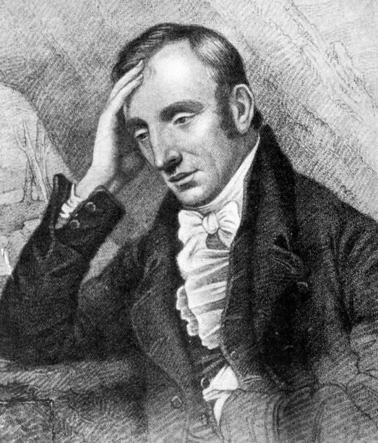

British Romanticism is usually divided into an early period and a late period; William Wordsworth is the best poet of the former, and John Keats of the latter. The Romantics reacted against the formalism, rationalism, and urbanism of the poets of the long eighteenth century, turning toward emotion, imagination, and nature. After rejecting the heroic couplet of the Augustans as too one-dimensional, the Romantics discover that a variety of poetic forms already exists within the tradition. Wordsworth renews the blank verse of John Milton, breathes new life into the almost forgotten form of the sonnet, and invents the verse autobiography. Keats, too, writes sonnets, as well as narrative poems in blank verse, and—in a return to the seventeenth century’s return to the origins of lyric—odes. In addition to renewing the tradition, Wordsworth and Keats are responsible for recovering the essential role of imagination in poetry, a restoration that remains with us today. Without it, Wallace Stevens would not have been able to say the following about poetry: “[imagination] has the strength of reality or none at all.”
We will read Wordsworth’s major narrative poems. We will also read The Prelude, an autobiography of his soul, paying closest attention to the 1805 version, while noting some of the differences in the 1799 and 1850 versions. His sonnets deserve careful attention, as do his letters and prose—he often writes about aesthetics and poetics. We will read Keats’ narrative poetry, namely, his Endymion and the two versions of his unfinished poem, Hyperion. However, it is through his lyric poetry that Keats endures. Like Shakespeare before him, and Stevens after, Keats creates an entirely new paradigm for lyric, and his sequence of odes is perhaps the greatest sequence in all of literature. Finally, we will read much of the prose of these two poets—Wordsworth’s prefaces; Keats’ extraordinary letters—as well as their standard biographies.

Requirements: seminar participation; short analyses of individual poems; 15-20 page seminar paper; final exam.

Reading List:
Poetry
William Wordsworth: The Major Works, Oxford UP
John Keats: The Major Works, Oxford UP

Biographies
Wordsworth: A Life, Juliet Barker (2006)
John Keats, Walter Jackson Bate (1963)
Recommended: The Keats Brothers: The Life of John and George, Denise Gigante (2011)

ENG 401-02: Novels of Charles Dickens
Dr. Dwight Lindley
M 2:00-4:50pm
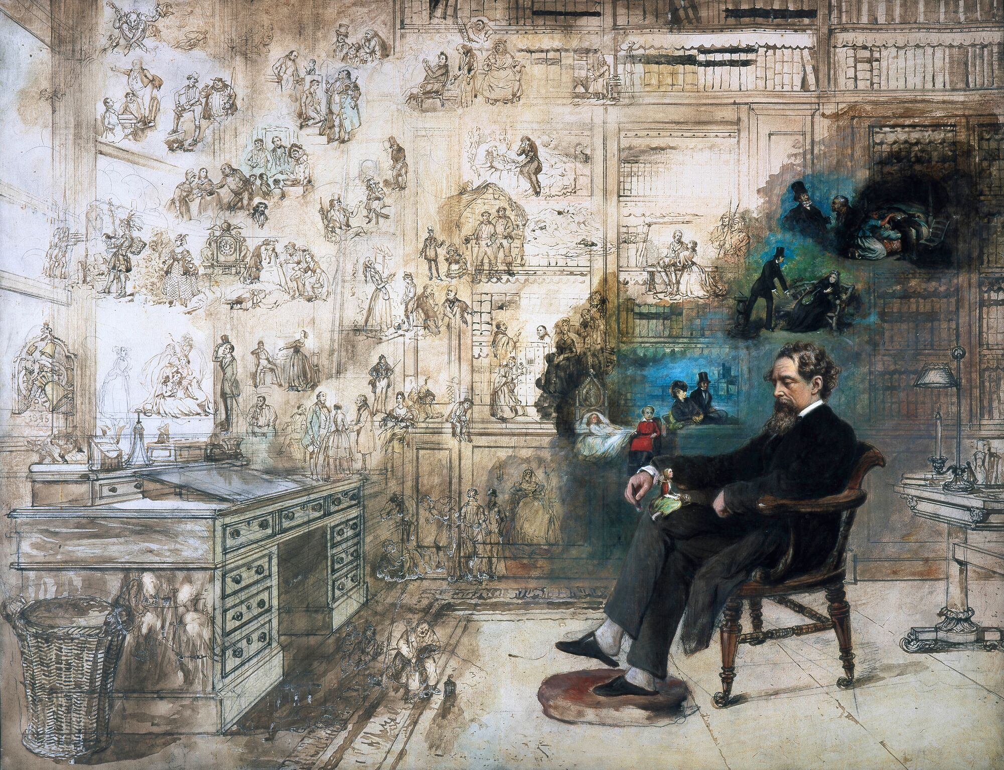
“The rise of Dickens,” wrote G.K. Chesterton, “is like the rising of a vast mob . . . . [H]is tales are indeed as crowded and populous as towns: for truly it was not so much that Dickens appeared as that a hundred Dickens characters appeared.” That is, like Shakespeare, Dickens is an author who lives for his characters, or better, enables them to live on their own in his books. It is possible in a Dickens novel, as in a Shakespeare play, to forget whose book you are reading, lost in the extravagant life of the characters; in Paradise Lost or a George Eliot novel, this would never happen. Because he was so excessively devoted to the dignity, greatness, and pathos of the human person, Dickens did have some blind spots literarily (Eliot’s plots, for example, are more tightly constructed, every character fitting into her place), but what he did see was truly magnificent: with Irenaeus of Lyons, Dickens could have affirmed that “the glory of God is a human being fully alive.” In this course, we will read several novels of Dickens closely, with a careful attention to his narrative art, but also to his conception of human nature and personhood.

Prerequisite: ENG 340, or permission by the instructor

Requirements: weekly reading quizzes, a handful of one-page narrative analyses, a comprehensive final examination, and a 15-20 page paper.
Reading List:
- Dickens, Charles. Dombey and Son. Edited by Lucy Hughes-Hallett. New York: Everyman’s, 1994. ISBN 978-0679435914.
- Dickens, Charles. David Copperfield. Edited by Michael Slater. New York: Everyman’s, 1992. ISBN 978-0679405719.
- Dickens, Charles. Bleak House. Edited by Barbara Hardy. New York: Everyman’s, 1991. ISBN 978-0679405689.
- Dickens, Charles. Our Mutual Friend. Edited by Andrew Sanders. New York: Everyman’s, 1994 ISBN 978-0679420286.
- Hartley, Jenny. Charles Dickens: A Very Short Introduction. Oxford: Oxford University Press, 2019. ISBN 978-0198714996.

ENG 402-01: Whitman and Dickinson
Dr. Kelly Scott Franklin
TTh 1:00-2:15pm

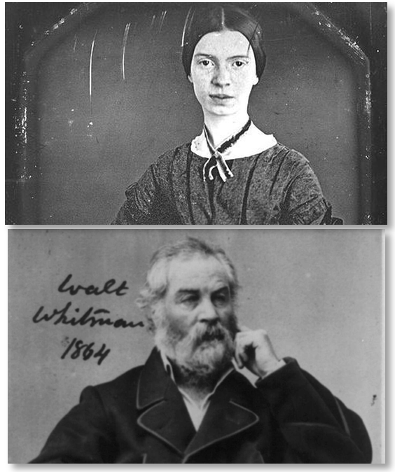
Whitman and Dickinson divide nineteenth-century American poetry between them. There is no third.

Yet these two writers occupy radically different poles of artistic life. Whitman launches expansive lines in a verse made for large-format books. Dickinson carves tiny poetic forms, even cramped physically onto the paper scraps she sometimes used for composition. Whitman publishes and republishes compulsively; Dickinson almost never. Whitman travels the country and strolls endlessly our American cities; Dickinson becomes a recluse. Whitman maintains a pose of bombastic optimism; Dickinson dramatizes skepticism and doubt. Whitman writes frankly about the body; Dickinson writes with painful honesty about the mind and heart. Writers ever since have had to navigate this literary Scylla and Charybdis to find their own voices.

This seminar pairs these two experimental poetic giants, with deep readings from their large corpus of works. The course will also examine how Whitman and Dickinson respond to contemporary currents (Transcendentalism, Social Reform, the Civil War) and to some of their own thematic concerns (love, sexuality, death, God, Nature, and poetry/authorship itself).

Prerequisite: ENG 360 or permission by the instructor

Requirements: daily informal writing responses; 5 page poem genealogy (textual criticism); 15-20 page seminar paper; Final Essay Exam.
ENG 402-03: The Novels of William Faulkner
Dr. Thea Autry
MW 4:15-5:45pm

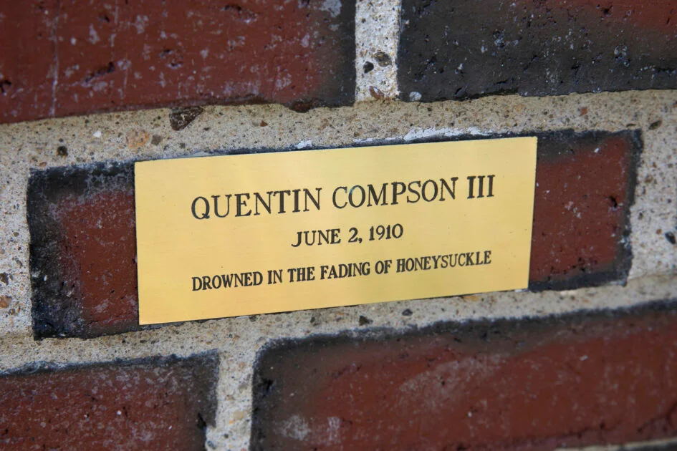
Jon Chase/Harvard
In 1965, donors installed at Great Bridge in Cambridge, Massachusetts a plaque memorializing the death of Harvard student Quentin Compson, one of William Faulkner’s most beloved fictional characters; in his 1929 novel The Sound and the Fury, the author describes Quentin’s suicidal leap from this bridge, and the site has attracted visitors ever since. Very rarely in American letters has an author so captured his readers’ imaginations. Indeed, it is difficult to identify a late 20th- or early 21st-century American author not touched by Faulkner’s influence. For this reason, any student of U.S. literature must explore the richness of Faulkner’s characters, the complexities of his region, the virtuosity of his narrative approach, and the contributing vicissitudes of his public and private lives. In this course, we will closely and critically read six of Faulkner’s most canonical works, as well as the second-most authoritative biography of the author (the most authoritative spanning an unmanageable 1800 pages). Summer reading includes The Sound and the Fury and David Minter’s William Faulkner: His Life and Work. The weekly reading load throughout the semester is expected not to exceed 110 pages. This is a discussion-based course.
Prerequisite: English 370 or permission of instructor
Requirements: two short essays, an eight-source annotated bibliography, a 17-page critical essay, and a final exam.
Reading List: David Minter’s William Faulkner: His Life and Work, and the following novels by William Faulkner: The Sound and the Fury; As I Lay Dying; Sanctuary; Light in August; Absalom, Absalom!; Go Down, Moses.

ENG 402-03: The Transcendentalists: Henry David Thoreau
Dr. Christopher Busch
MWF 11:00-11:50
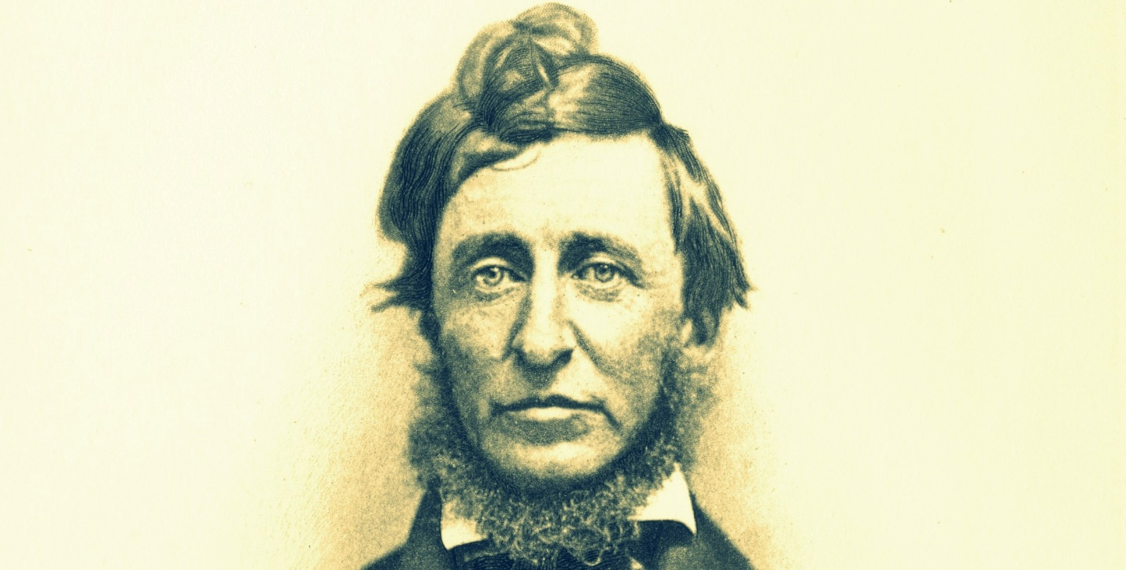
This course will focus primarily on Thoreau’s writings, including Walden, Civil Disobedience, “Walking,” and possibly A Week on the Concord and Merrimack Rivers. As background, we will begin with Emerson: Nature, “The American Scholar,” “The Divinity School Address,” and likely include some brief readings from others: Margaret Fuller, Elizabeth Peabody, Bronson Alcott, possibly a few others excerpted in Perry Miller’s The Transcendentalists. We will also read selections from Robert Gross’s new (2021) book, The Transcendentalists and Their World and Laura Dassow Walls’ biography, Henry David Thoreau: A Life (2017).
Requirements: the course is a seminar, with two papers (the first shorter, 5-7 pages, the second longer, a seminar paper with annotated bibliography). There will also be a final exam. Students will each be responsible for researching/presenting critical material (articles, chapters, etc.) to inform the discussion of one class session.

ENG 403-01: Dostoevsky
Dr. Justin Jackson
T 2:30-5:30pm

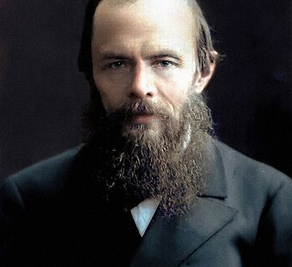
“He is the Shakespeare of the lunatic asylum”
—Viscount Melchior de Vogue

In this seminar, students will investigate several of the major works of Fyodor Dostoevsky. Though the literature will not be taught in a strict chronological fashion, we will work through some of his early writings to illustrate the seeds of his spiritual and psychological insights which give way to the fruits of Dostoevsky’s prophetic vision. We will begin our reading with The Double (1948), an early work panned by critics but which Dostoevsky recognized as crucial to his poetic and psychological vision. From here, we will turn to his major literary breakthrough (though not fully appreciated in its own time), the first of his fruits as it were, Notes from Underground. From here, we will move out from the Dostoevskyan “underground” (though one never really leaves it) to his vision of suffering and redemption—indeed, of paradise itself. Of his major novels we will read Crime and Punishment, The Idiot, and The Brothers Karamazov. We will pair each novel with one of his shorter works and investigate the way in which he crafts his poetic, psychological, and/or theological vision. We will also read various writings from two important literary theorists, Mikhail Bakhtin and René Girard, both of whom have shaped the way other critics and even translators have understood Dostoevsky.
Prerequisites: one 300-level English course; a sturdy soul.
Requirements: on the first night of class, students will be given an exam covering The Double, Notes from Underground, Crime and Punishment, The Idiot, and The Brothers Karamazov; students will participate regularly on a message board; annotated bibliography; seminar paper of 23+ pages; final exam.

ENG 403-02: Comedy
Dr. David Whalen
TTh 2:30-3:45pm

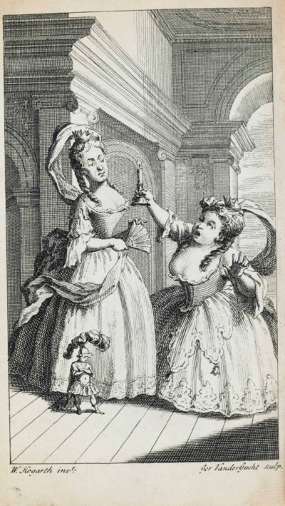
’Tis better to write of laughter than of tears,
Since laughter is the property of Man.
—Rabelais

Dramatic comedy, the oft-slighted sibling of tragedy, boasts a rich history in the western literary tradition. This course will take up the genre and, while paying attention to its history, focus primarily on great examples of comedy as “serious” explorations of human experience. We will address a number of sub-genres such as farce, burlesque, Old Comedy, interlude, romantic comedy, comedia erudite, comedy of manners, comedy of humors, satire, comedy of the absurd, etc. The course will likewise consider some of the theoretical or philosophical treatments of comedy and closely-related topics such as humor, wit, and laughter. Representative authors include Aristophanes, Plautus, Machiavelli, Shakespeare, Jonson, Moliere, Wycherley, Congreve, Fielding, Chekhov, Wilde, Coward, and Stoppard. Other authors, ranging from Plato and Aristotle through Bakhtin and Frye will inform our theoretical discussions.
Prerequisite: A 300-level English course or permission of the instructor.
Requirements: a midterm and final exam, an amputated (sic) bibliography, and a 15-20 page paper.

ENG 597-01: Minding the Memory Hole: 1984 in 2022 (one credit)
Dr. Patricia Bart
Th 7:30-8:30pm

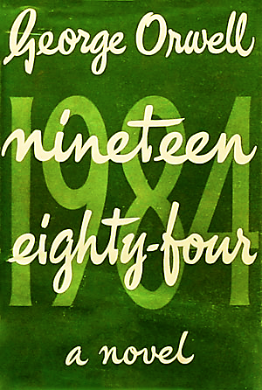
Thought crime. Memory hole.
Unperson. Newspeak.
Facecrime
If you have been disturbed by the recent surge in routine censorship, the extreme throttling of public debate on weighty matters of national and international importance, the weaponization of the judicial system against citizens voicing their concerns at public meetings, and the recent massive curtailment of civil liberties across the board, then it is time you read Orwell’s twentieth-century dystopian masterpiece, 1984.
In this 1-credit seminar, weekly discussions of the work chapter by chapter will focus on the nature and means of the state’s control over Winston Smith: material, economic, technological, physical, social, linguistic, emotional, spiritual—and on the means that Winston either possesses or lacks for resisting these powers.

Conversation will be based on very close readings of the work, but we will aim to apply what we learn from the work to specific modern instances of similar phenomena, considering how they have changed, and how they have remained similar to what Orwell envisioned seventy-three years ago, during the early years of the Cold War. Our discipline in this will be not only to critique those people and phenomena we think are operating in the spirit of Winston’s nemesis, O’Brien, but also to consider how Big Brother may have his hooks into us as well.
Have you ever said that you saw five fingers, when there really were only four?
Requirements: a 5-7 page paper; final examination: 1 essay on a pre-announced topic.
Image first edition cover, public domain; gazing eye, courtesy of what is arguably the biggest hook.

Summer Session I, 2022

ENG 201-01: Great Books in Continental Literature
Dr. Patricia Bart
MTWThF 1-4pm

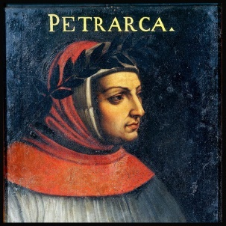
Petrarch lived well into the Italian Renaissance, yet he is famous for having declared himself to be living in a “middle age”—one between the era of Rome’s ancient greatness, and one in which that greatness would be reborn, whence comes the foundation of our notion of the most recent Western “renaissance.” Hence, works by Petrarch such as the “Triumph of Eternity,” Secretum, and “The Ascent of Mount Ventoux” form a bridge from the generation of Dante to that of Giovanni Pico della Mirandola and the Renaissance humanists of later years.
Beginning, then, with Petrarch’s “middle age,” which is consciously (albeit gradually) saying goodbye to the Middle Ages proper, we will commence our walk through the corridors of Western Continental literature by visiting Miguel de Cervantes’ Don Quixote, Lope de Vega’s El caballero de Olmedo (The Knight from Olmedo), and Racine’s Athalie (Athaliah). These we will round off with retrospection, under the aegis of Juan de la Cruz’s “La noche oscura del alma” (“The Dark Night of the Soul”).
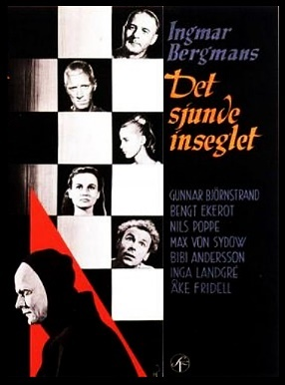
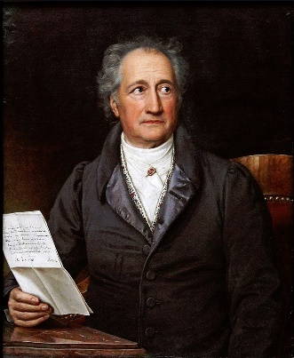
At the mid-point, we will sojourn among the Germans, reading poets such as Goethe, Schiller, Heine, Eichendorff, Mörike, and Rilke, taking time to appreciate both the written and the musical tradition, including some exploration of Schubert’s Lieder settings, Die Schöpfung (The Creation) by Haydn, and some passages from Wagner’s operas, because German literature is intimately bound to German song and to instrumental culture.
Our visit with later authors will include Die Verwandelung (The Metamorphosis) by Kafka, and works such as Gustave Flaubert’s Trois contes (Three Stories) and Georges Bernanos’ Journal d'un curé de campagne (Diary of a Country Priest). This time, we will round our reading off with Ingmar Bergman’s classic Swedish masterpiece, Det sjunde inseglet (The Seventh Seal) which, figuring forth the desolation of the twentieth century, bears important similarities to and differences from Juan de la Cruz’s gaze into the darkness—making for a double retrospection.

Requirements: One paper responding to a primary text from the syllabus, 5-7 pp., with a research/secondary literature element fully optional. Midterm and final examinations: 1 essay each on a pre-announced topic, written during the first hour of class.

Reading Assignments: These will be carefully adjusted to the summer schedule. There will be options for convivial live readings in the evenings—outdoors when possible—as well as some “cold readings” from the plays and vocal performance of some of the poems during class. Our aims will emphasize enjoyment of the literature in a relaxed atmosphere.

ENG 360-01: American Literature: 1820-1890
Dr. Kelly Franklin
MTWThF 12-3pm

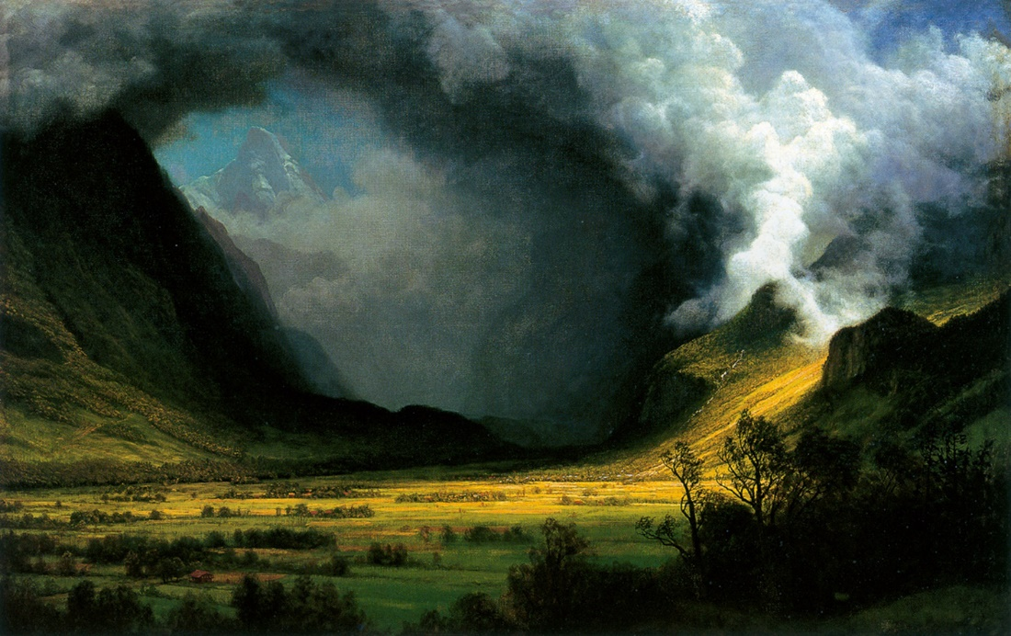
In January of 1820, the acerbic English clergyman Sydney Smith asked sardonically in The Edinburgh Review, “In the four-quarters of the globe, who reads an American book?” Emerson and Hawthorne were teenagers. Frederick Douglass was a toddler. Whitman and Melville were one-year-olds. Emily Dickinson wouldn’t be born for another decade. Mark Twain’s parents weren’t even married yet.

This class tells the story of how American literature came to be.

Requirements: informal online discussion responses; close reading analysis; 12-15 page research paper; annotated bibliography; final essay exam.

ENG 370-01: American Literature: 1890 to Present
Dr. Brent Cline
MTWThF 9-12

If the 20th century witnessed the rise of America's political power, the country's literary explosion was no less impressive. In this introduction to naturalism and modernism, we will try to experience some part of the wide range of America's literary output. Readings will include Ernest Hemingway, William Faulkner, Arthur Miller, Flannery O'Connor, Ralph Ellison, J.D. Salinger, and Toni Morrison.

Requirements: annotated bibliography, short close readings, final paper (10-12 pages), and comprehensive final.

ENG 403-01: Reading Biblical Narrative
Dr. Justin Jackson
MTWThF 9-12am

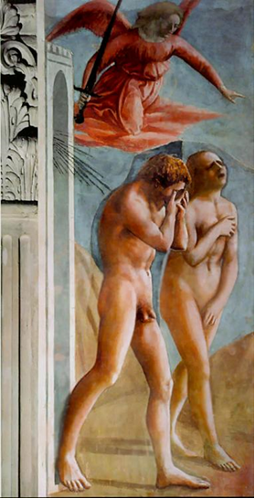
This course is designed to give the student a solid literary foundation in a broad range of texts from the Hebrew Bible and will provide the student with various examples of Biblical exegesis—from New Testament sources, from early rabbinic sources, and from sources from the early Christian Church. While the focus in the course is primarily on biblical narrative, we will also focus on the art of biblical poetry as well—since much of biblical narrative is comprised of biblical poetry. Additionally, we will study the physical setting of the biblical narratives, cultural/historical settings, and important mythic and anti-mythic narrative patterns throughout.

Requirements: Message board participation; 15-page seminar paper; final exam.

ENG 403-02: Augustinian Narrative
Dr. Dwight Lindley
MTWThF 1-4pm

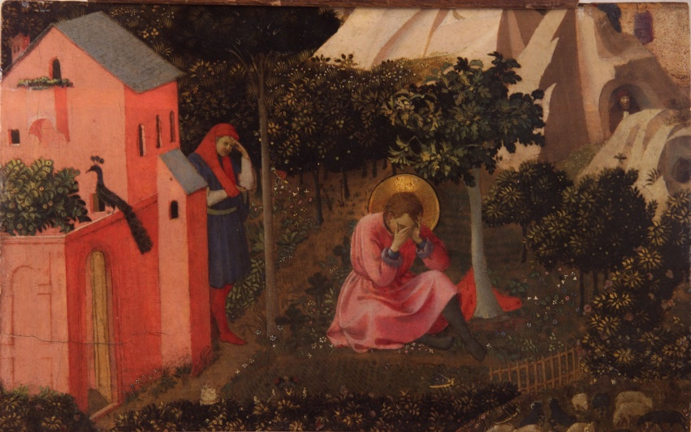
When C.S. Lewis wrote that “Milton’s version of the Fall story is substantially that of St Augustine,” he meant that Milton had borrowed a great deal from The City of God in designing Paradise Lost. In fact, an attentive reading of Augustine’s Confessions and City of God in light of the later literary tradition reveals that a great many of our favorite works owe more to this Father of the Church and his narrative imagination than is usually acknowledged. Not only Milton, but Dante, Shakespeare, Austen, T.S. Eliot, and many others, owe a great deal to Augustine’s narratives, whether directly or indirectly. His presentation of the falls, conversions, and redemptions so common to human experience has colored subsequent storytelling far more than is usually realized. With that premise in mind, we will spend our time this summer term giving a close reading to the Confessions, as well as substantial portions of the City of God, with an eye to their narrative logic, the interplay between character, plot, voice, etc., and the theological foundations of Augustine’s imagination. As we go, we will consider not only Augustine’s own way of thinking and writing, but choice later works that were influenced by him.

Booklist:
- Augustine. The Confessions. Translated by Maria Boulding. 2nd Ed. Hyde Park, NY: New City Press, 2012. ISBN 978-1565484450.
- Augustine. The City of God against the Pagans. Translated by R.W. Dyson. Cambridge: Cambridge University Press, 1998. ISBN 978-0521468435.

Requirements: participation and discussion-leading; annotated bibliography; 15-page paper; final exam.

Summer Session II, 2022

ENG 370-01: American Literature: 1890 to Present
Dr. Kelly Franklin
MTWThF 12-3pm

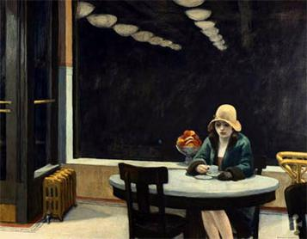
“A Pact”
by Ezra Pound

I make truce with you, Walt Whitman—
I have detested you long enough.
I come to you as a grown child
Who has had a pig-headed father;
I am old enough now to make friends.
It was you that broke the new wood,
Now is a time for carving.
We have one sap and one root—
Let there be commerce between us.

This course tells the story of how the writers of the late-nineteenth century to the present took the “new wood” broken by Whitman’s era, and began to carve. Authors include Crane, London, Gilman, Wharton, Eliot, Frost, Williams, Hemingway, Ellison, Faulkner, O'Connor, Wiman, and others.

Requirements: informal online discussion responses; close reading analysis; 12-15 page research paper; annotated bibliography; final essay exam.

ENG 403-01: Hospitality in the Western Tradition
Dr. Patricia Bart
MTWThF 1-4pm

The innkeeper asked if he had any money. Don Quixote said that he didn’t have a [penny], because he’d never read in the histories of knights errant that any one of them had taken money with him. To this, the innkeeper said that he was mistaken, because, although the histories didn’t specify something as obvious and necessary as money and clean shirts, there was no reason to believe that they didn’t have them. Thus he could consider it certain and proven that all knights errant—of which so many books of chivalry are filled—carried well-stocked purses for any contingency, and that they also took clean shirts . . .
—from Don Quixote 1.1.3
Don Quixote was right. Although inns did exist that offered lodging in exchange for money in the middle ages, a knight would not be likely to need one in the way a military officer or officer of the law would today. Why not? How could a knight—or Odysseus or Aeneas—show up at a fine residence expecting to be fed and clothed without question, just by dropping in?
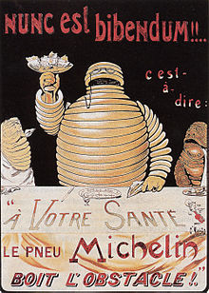
Although this seminar would not properly be called a course in partying, it does deeply consider the fundamental role of parties—among many other forms of hospitality—in Western Civilization, from ancient times to the present. Texts considered will include but not be limited to Genesis, Psalms, the Gospels, The Odyssey, Symposium, Politics Book I, Aeneid, and Horace’s Ode 1.37 (Nunc est bibendum) along with medieval, early modern, and modern texts such as the Middle French Quest of the Holy Grail, “Sir Gawain and the Green Knight,” Ben Jonson’s “To Penshurst,” and selections from among the works of William Shakespeare, Jane Austen, Charles Dickens, William Wordsworth, James Joyce, Josef Pieper, and others.
How did we move from the idea of hospitality as a virtue—and as a major opportunity for either virtue signaling or for truly self-giving charity—to hospitality as an industry—a prime opportunity to make money by providing a service? How did hospitals drift so far away from the idea of hospitality even as an industry?
We will ponder hospitality as it either is or is not presented in the texts themselves, nested within the historical conditions from which the texts arose. This textual-historical study will be augmented importantly by considerations of hospitality’s practical significance in the real, material world. What are the material and spiritual conditions in which this virtue flourishes? Each week will include sessions that cover the practicalities of hosting, which are usually left tacit in the texts, to better enable students to enter into the worlds seen in the religious, philosophical, and literary works under study.
The Paper: A 15-page analysis paper interpreting a work on the syllabus will point to how our present circumstances relate to the fictional and historical world of that work. In view of the limited summer time frame, students may restrict the research element to as little as a single secondary source.
The Examination: A pre-circulated question will elicit an argument essay in response, which reviews selections from among the assigned works. Students will prepare a typed-out list of quotations (prepared at leisure) to support their responses, which will be written out during the last class period.

English Department Course Forecast: Spring 2023
NB: This is a forecast, subject to change if circumstances require. Check with the chair and professor for the most up-to-date planning information on next Fall.

Course Number/Name | Instructor
ENG 310 | Jackson
ENG 320 | Timmis
ENG 330 | Kearney
ENG 340 | Lindley
ENG 360 | Franklin
ENG 370 | Autry
ENG 370 | Busch
ENG 401: Modern Irish Poetry | Fredericks
ENG 401: Shakespeare | Smith
ENG 402: Cormac McCarthy | Cline
ENG 402: Henry James | Murphy
ENG 403: History of the English Language | Bart
ENG 403: Tragedy | B. Whalen
ENG 403: The Catholic Novel | Peters

